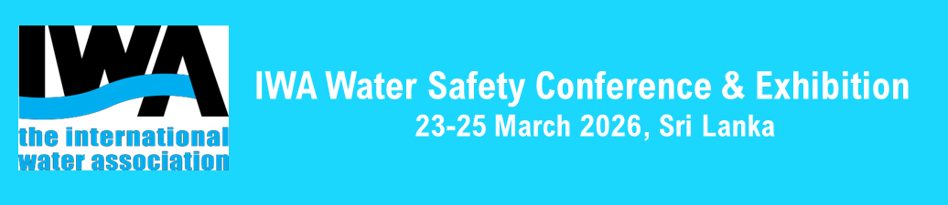WORKSHOP OUTLINE PROPOSAL
Workshop in short
Workshop Title | Add the title of the workshop
Session Chairs and Co-Chairs | List the name/s of the workshop organisers and their affiliations
Speakers/Panelist | List the speakers/panelists, who will be invited to the workshop, along with their areas of expertise and affiliations
Keywords/key topics | List the key topics and words related to the proposed objectives and outcomes of the workshop.
Objectives | List the objectives of the workshops  - Objective 1  - Objective 2 etc.
Session Summary | Provide a concise summary of the proposed workshop in no more than 500 words
Learnings/ Outcomes | List the expected learnings/outcomes from the workshop  - Outcome 1  - Outcome 2 etc.
Session Format | For example, 60-90 minutes workshop relevant to water utilities, researchers, regulators, policy makers, water and sanitation professionals:  ☐ Panel discussion  ☐ Roundtables discussion  ☐ World Cafe  ☐ Other; case example presentation, short groupwork, interactive experience sharing and Q&A
Preferred Room Layout | ☐ Theatre Style  ☐Roundtables  ☐ Other. Which_________________________
Preferred Supporting Materials | Flip charts, white boards, markers

IMPORTANT NOTE: IWA’s inclusive values promote the principle of equitable geographical distribution and the desirability of gender and age balance. Therefore, during the development of the proposal, we encourage to consider these values in the selection of the workshops organisers/partners, chairs and speakers.

